Output:

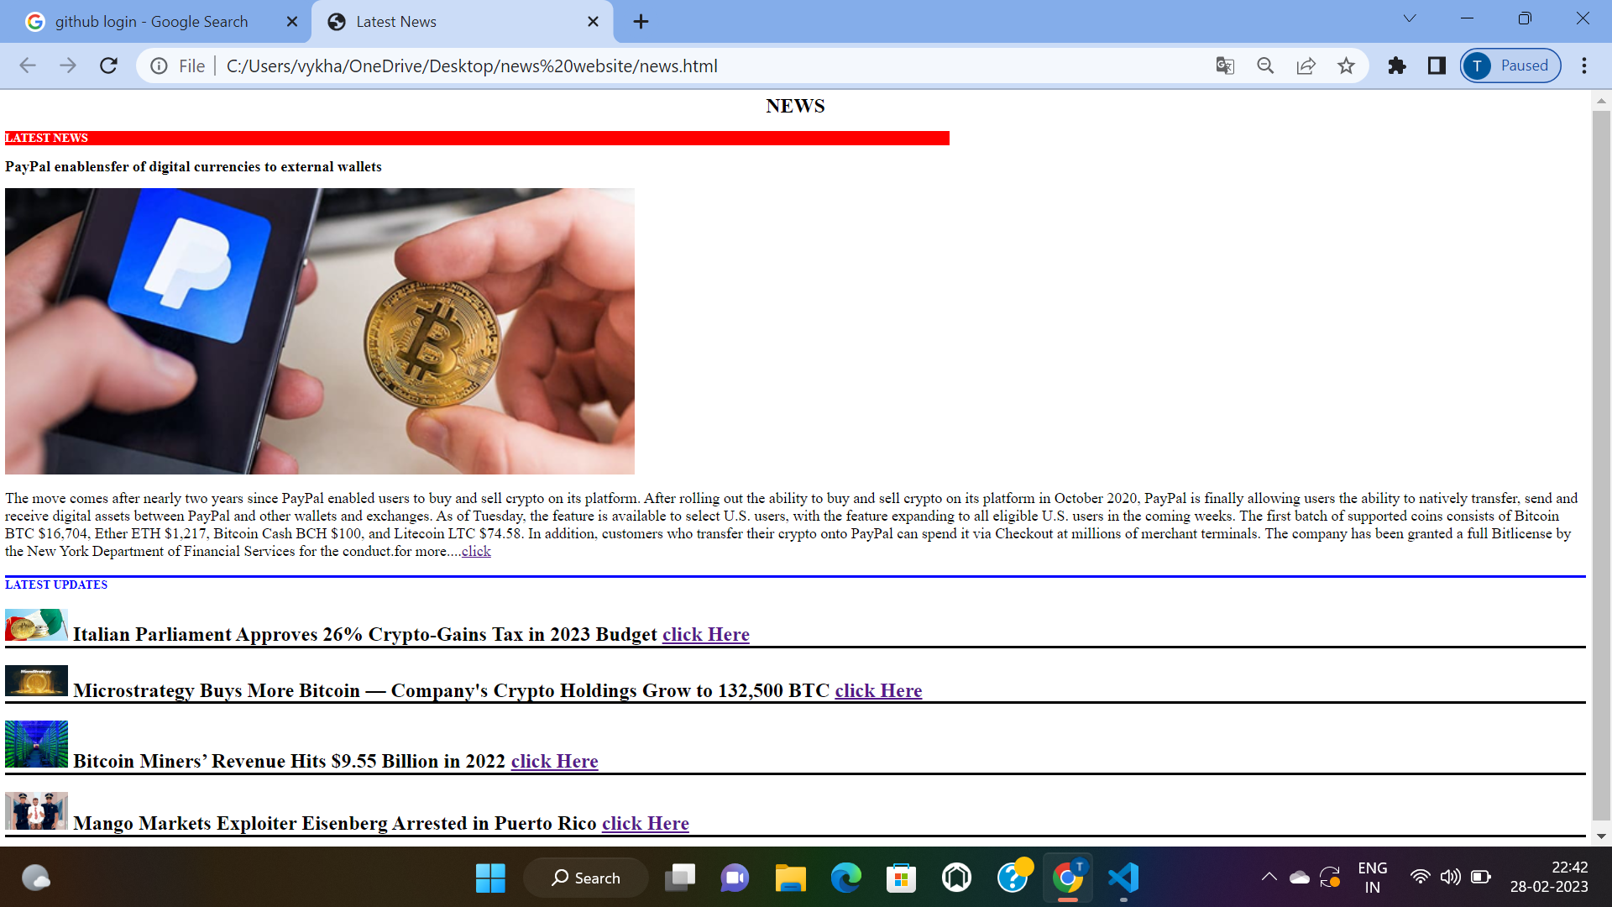

We have to choose any of the news in the below latest updates then we shift to that page.

For example we choose Mango market news and click on click here then output will display as below

